**Name = Mayuresh M kodape**

**Project 3:  
Task 1:**Login to metaspolit and extract ip address  
**Task 2:** Do nmap scanning on the IP, Extract Open port and Version Details  
**Task 3:**Check the vulnerable version exploitation's procedure in rapid7 and start exploiting the following ports  
A)Telnet  
B)FTP  
C)SSH

**Task 1:**Login to metaspolit and extract ip address

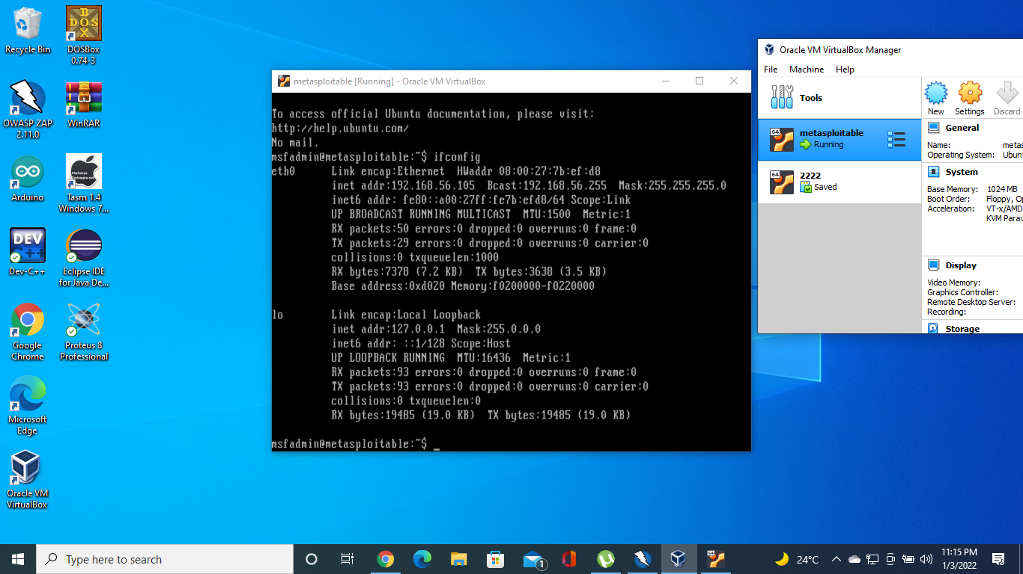

**Task 2:** Do nmap scanning on the IP, Extract Open port and Version Details

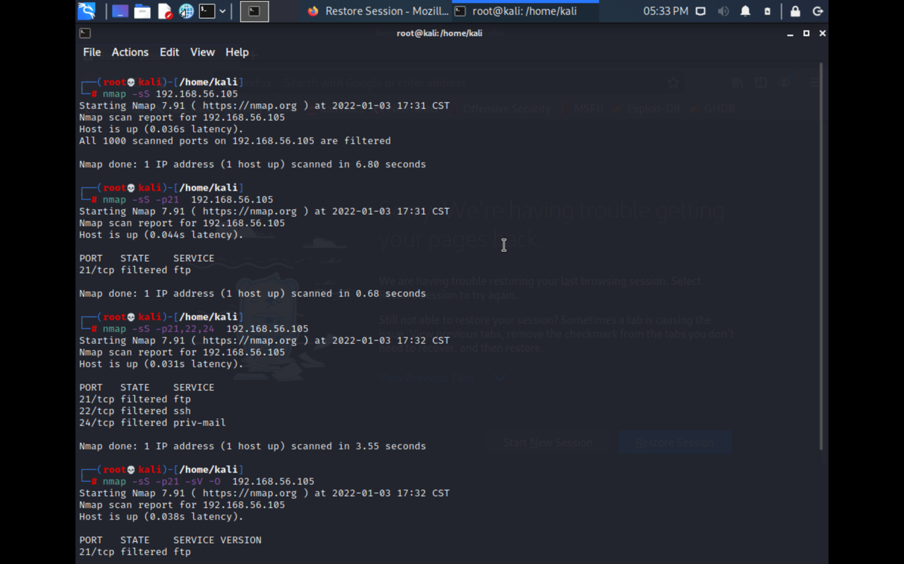

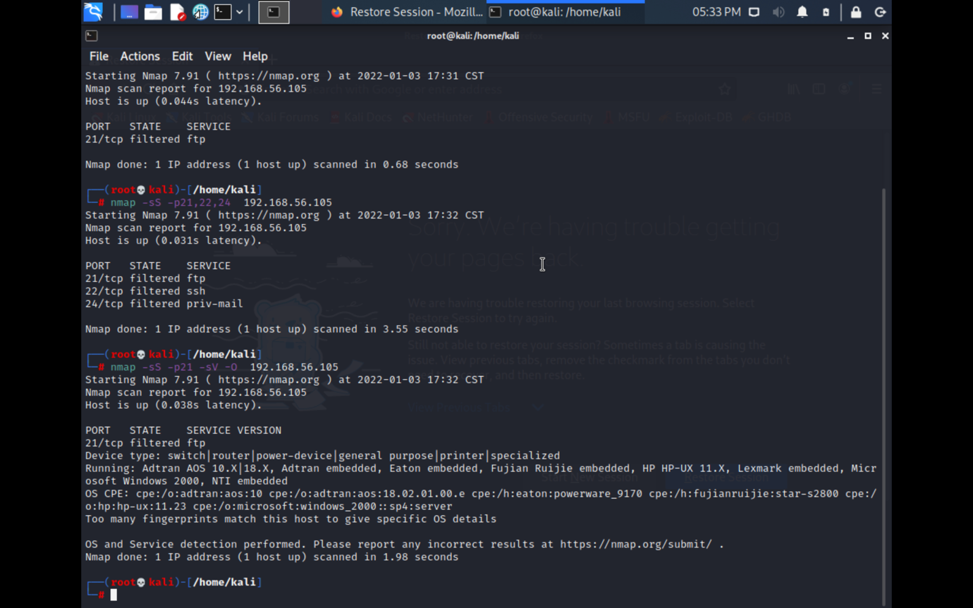

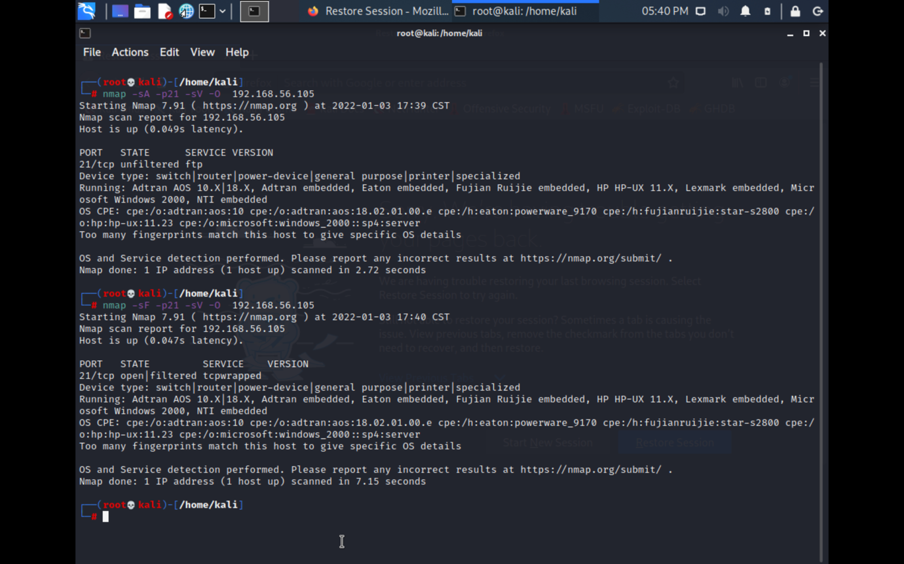

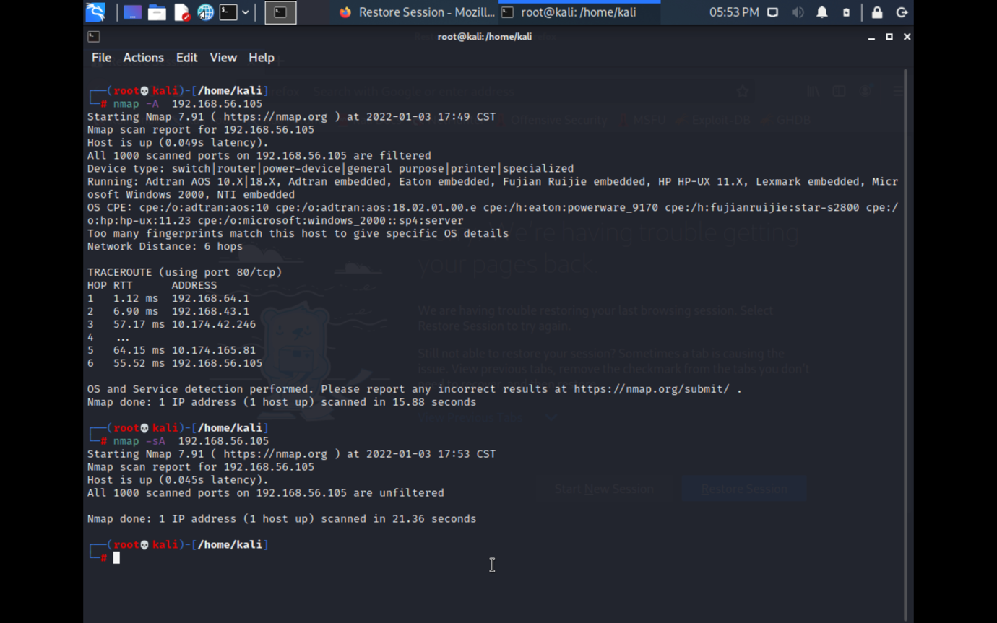

**Task 3:**Check the vulnerable version exploitation's procedure in rapid7 and start exploiting the following ports  
A)Telnet  
B)FTP  
C)SSH

A)FTP

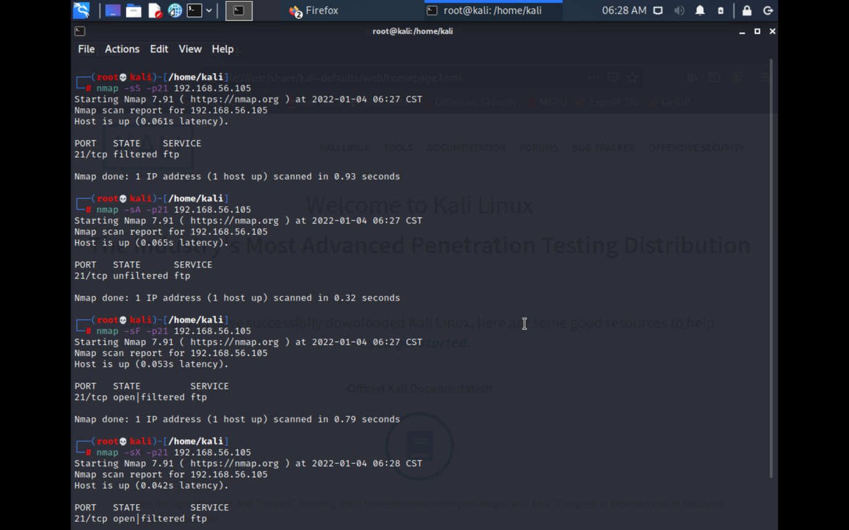

C)SSH

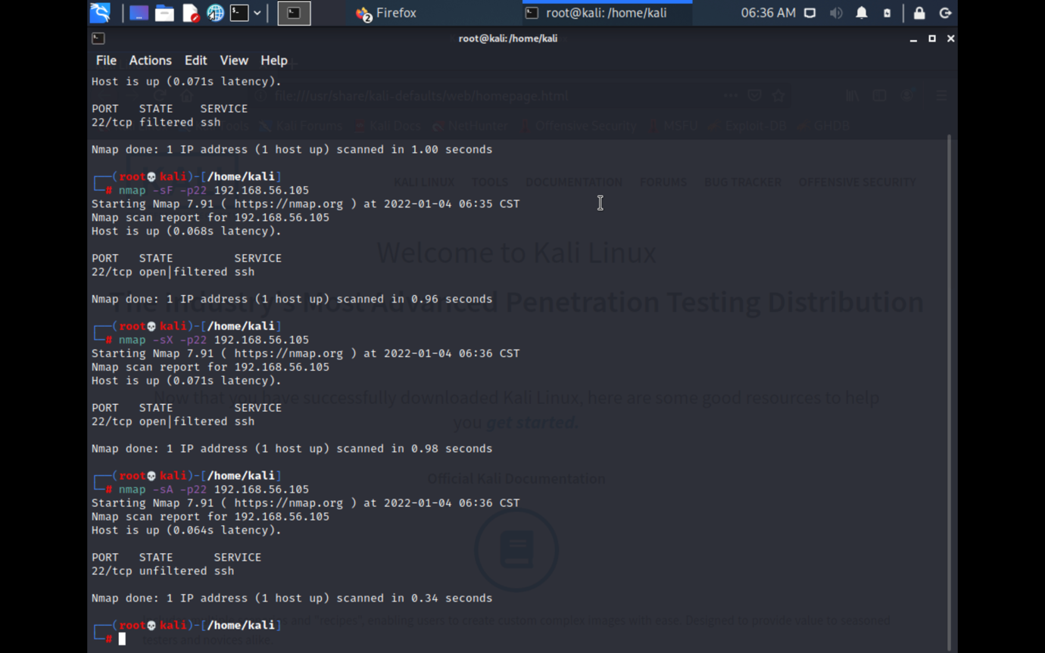

B)Telnet  
